INVENTION DISCLOSURE FORM

This form serves only the purpose of facilitating an inventor to disclose his invention for filing of Application for Patent. The information provided herein would be treated under strict confidentiality.
- INVENTOR(S) DETAILS:

Name | Jhenkar G R
Designation | Student Researcher, Department of Information Science and Engineering (USN: 1JS23IS060)
Nationality | Indian
Address | Department of Information Science and Engineering, JSS Academy of Technical Education, Dr. Vishnuvardhana Main Road, Srinivasapura, Bengaluru, Karnataka, India - 560060
Email Id | 1js23is060@jssateb.ac.in
Telephone | +91-80-28612565 / +91-9448000000 (Available upon request)
Name | Dhanush H S
Designation | Student Researcher, Department of Information Science and Engineering (USN: 1JS23IS036)
Nationality | Indian
Address | Department of Information Science and Engineering, JSS Academy of Technical Education, Dr. Vishnuvardhana Main Road, Srinivasapura, Bengaluru, Karnataka, India - 560060
Email Id | 1js23is036@jssateb.ac.in
Telephone | +91-80-28612565
CO-INVENTOR 3 DETAILS:
Name | Gagan G Pawar
Designation | Student Researcher, Department of Information Science and Engineering (USN: 1JS23IS046)
Nationality | Indian
Address | Department of Information Science and Engineering, JSS Academy of Technical Education, Dr. Vishnuvardhana Main Road, Srinivasapura, Bengaluru, Karnataka, India - 560060
Email Id | 1js23is046@jssateb.ac.in
Telephone | +91-80-28612565
CO-INVENTOR 4 DETAILS:
Name | Harsha L
Designation | Student Researcher, Department of Information Science and Engineering (USN: 1JS23IS053)
Nationality | Indian
Address | Department of Information Science and Engineering, JSS Academy of Technical Education, Dr. Vishnuvardhana Main Road, Srinivasapura, Bengaluru, Karnataka, India - 560060
Email Id | 1js23is053@jssateb.ac.in
Telephone | +91-80-28612565
FACULTY MENTOR &amp; CO-INVENTOR DETAILS:
Name | Dr. Nagashree S
Designation | Assistant Professor & Project Guide, Department of Information Science and Engineering
Nationality | Indian
Address | Department of Information Science and Engineering, JSS Academy of Technical Education, Dr. Vishnuvardhana Main Road, Srinivasapura, Bengaluru, Karnataka, India - 560060
Email Id | nagashrees@jssateb.ac.in
Telephone | +91-80-28612565
- APPLICANT (Ownership) DETAILS (if same as inventor(s), indicate as above):
Name Of Company | JSS Academy of Technical Education, Bengaluru (JSS Mahavidyapeetha, Mysuru)
Nationality | Indian
Address | JSSATE Campus, Dr. Vishnuvardhana Main Road, Srinivasapura, Bengaluru, Karnataka, India - 560060
Email Id | info@jssateb.ac.in / principal@jssateb.ac.in / hodise@jssateb.ac.in
Telephone | +91-80-28612565 / +91-80-28611702
- Brief on the Technical Field of the Invention:
The present invention relates generally to artificial intelligence, applied machine learning, computer vision, and retail operations management. More specifically, the invention relates to an autonomous closed-loop growth and operational intelligence platform designed for Small and Medium Enterprises (SMEs) such as neighbourhood cafés, boutique retailers, and wellness salons.
The system bridges the gap between digital consumer trends and physical store execution by synthesizing multi-platform social media listening, stationary rate-of-change (velocity-based) trend forecasting, intermittent retail demand planning (blended Poisson and Teunter-Syntetos-Babai models), zero-marginal-cost multimodal generative advertising, edge optical character recognition (OCR) receipt ingestion, and proactive multi-channel stockout alerting into a single unified bi-directional architecture.
International Patent Classification (IPC) Codes: G06Q 10/08 (Logistics; Inventory management and stock replenishment), G06Q 30/02 (Marketing, market research, trend analysis, and advertising), G06N 3/08 (Artificial Intelligence and Machine Learning models), G06F 17/18 (Complex mathematical operations; Time series and statistical analysis), G06V 30/10 (Optical Character Recognition applied to commercial receipts and invoices), and H04L 67/10 (Distributed computing networks and serverless database model synchronization).
- Proposed TITLE of the Invention:
AN ARTIFICIAL INTELLIGENCE-DRIVEN CLOSED-LOOP RETAIL INTELLIGENCE PLATFORM AND METHOD FOR REAL-TIME SOCIAL TREND FORECASTING, AUTONOMOUS INVENTORY REPLENISHMENT, AND GENERATIVE MULTIMODAL MARKETING FOR ENTERPRISES
- Is a patent or literature search already conducted? If yes, cite the relevant documents (patent/non-patent):
Yes, a thorough patent and literature prior art search was conducted across IEEE Xplore, Google Patents, Espacenet, and ACM Digital Library. The investigation confirms that existing solutions treat social media listening, demand planning, and creative marketing as disconnected point products. The following relevant non-patent and patent documents were identified:
Relevant Non-Patent Literature (IEEE & Springer Publications):
• [1] N. Tiwari and S. K. Prasad, "Agentic AI-Driven Optimizing Demand Forecasting in Retail Systems with AI-Based Predictive Analytics," in 2025 International Conference on Artificial Intelligence and Machine Vision (AIMV), Gandhinagar, India, 2025. — Explores predictive demand analytics for large retail chains; lacks hyper-local social listening, creative ad workflows, and SME edge receipt digitization.
• [2] B. Jamalpur, S. H. Krishna, R. Bhat, S. B. Prasad, S. Bhattacharya, and D. Kapila, "AI in Social Media Marketing: Using Machine Learning to Analyze Trends and Predict Consumer Sentiment," in 2025 International Conference on Pervasive Computational Technologies (ICPCT), Greater Noida, India, 2025. — Evaluates sentiment on social platforms but fails to link sentiment scores to inventory ledgers or stock replenishment.
• [3] N. Tomar, K. Sahu, V. Kumar, and A. Srivastava, "AI Integrated Recommender System for Improving e-commerce Experience," in 2025 IEEE 14th International Conference on Communication Systems and Network Technologies (CSNT), Bhopal, India, 2025. — Focuses strictly on digital product recommendation and misses physical store stockout constraints and micro-influencer discovery.
• [4] A. Dunton, R. Vyas, H. Shah, S. Sankathala, and M. Masum, "InvadeAI: INteractive ADvertising with Multimodal AI," in 2025 IEEE Conference on Artificial Intelligence (CAI), Santa Clara, CA, USA, 2025. — Synthesizes dynamic multimodal ads but does not account for physical inventory availability or social trend velocity.
• [5] K. Singhal et al., "Smart Retail: Utilizing Machine Learning for Demand Prediction, Price Strategy, and Inventory Management," in Proc. IEEE Int. Conf. Computational Intelligence and Communication Networks (CICN), 2024. — Enterprise-level demand prediction requiring massive historical data; fails for intermittent SME retail demand.
• [6] G. Sood, "Utilizing Machine Learning for Predictive Sales Forecasting," in Proc. IEEE Int. Conf. Computing Communication and Networking Technologies (ICCCNT), 2024.
• [7] V. Suryawanshi et al., "Sales Forecast Prediction Using Machine Learning," in Proc. IEEE Intelligent Systems and Machine Learning Conf. (ISML), 2024.
• [8] N. P. Nagaraj et al., "Instagram-Driven Social Media Trend Forecasting with Learning Algorithm Using Live Dataset," in Proc. IEEE Int. Conf. Data Science, Agents & Artificial Intelligence (ICDSAAI), 2023.
• [9] H. C. Hewage and H. N. Perera, "Comparing Statistical and Machine Learning Methods for Sales Forecasting During the Post-promotional Period," in Proc. IEEE Int. Conf. Industrial Engineering and Engineering Management (IEEM), 2021.
• [10] V. A. Rohani, S. Shayaa, and G. Babanejaddehaki, "Topic modeling for social media content: A practical approach," in 2016 3rd International Conference on Computer and Information Sciences (ICCOINS), Kuala Lumpur, Malaysia, 2016.
Relevant Patent Prior Art:
• US Patent App. US 2021/0256578 A1: "System and Method for Supply Chain Demand Replenishment Based on Search Volume Trends" — Focuses on search query volume for enterprise warehouses; does not utilize velocity-differenced momentum damping, zero-disk DB model sync, or multimodal generative advertising.
• US Patent US 10,860,956 B2: "Method and System for Tracking Consumer Brand Perception Across Social Platforms" — Restricted to descriptive brand sentiment reporting without operational feedback loops to physical retail inventory or automated receipt OCR digitization.
• US Patent App. US 2023/0105822 A1: "Automated Generative Advertising and Visual Asset Synthesis for Digital Retail" — Synthesizes ad creatives in isolation, creating severe risks of advertising products that are currently stocked out.
- Any other articles relevant to your invention:
Additional foundational methodologies informing this invention include:
1. Teunter, Syntetos, and Babai (2011): "Intermittent demand: Linking forecasting to inventory obsolescence," European Journal of Operational Research, 214(3), 606-615. Establishes the mathematical TSB method that separates demand probability updating from demand size updating.
2. Friedman, J. H. (2001): "Greedy function approximation: A gradient boosting machine," Annals of Statistics, 29(5), 1189-1232. Provides the Poisson-loss distribution framework implemented in the HistGradientBoostingRegressor.
3. Sanh et al. (2019): "DistilBERT, a distilled version of BERT: smaller, faster, cheaper and lighter," arXiv:1910.01108. Basis for the high-speed transformer sentiment model in the dual ensemble pipeline.
4. Hutto & Gilbert (2014): "VADER: A Parsimonious Rule-based Model for Sentiment Analysis of Social Media Text," Proc. of the 8th International AAAI Conference on Weblogs and Social Media (ICWSM-14).
- List relevant Companies/Competitors in the field of similar invention to your knowledge:
Existing commercial players in adjacent spaces include:
• 1. Social Listening Platforms: Sprout Social, Hootsuite, Brandwatch, Meltwater, and BuzzSumo. These platforms provide macroscopic sentiment charts and keyword trackers. However, they lack any integration with retail point-of-sale systems, store inventory ledgers, or purchase order generation.
• 2. Enterprise Supply Chain Planning: Blue Yonder (formerly JDA), SAP Integrated Business Planning (IBP), Kinaxis RapidResponse, and Manhattan Associates. These systems cost upwards of $100,000 to deploy, rely on years of clean corporate ERP history, and cannot process ephemeral hyper-local social media trends.
• 3. Point of Sale & E-Commerce Systems: Shopify (Shopify Magic / Sidekick), Square (Block POS), and Lightspeed Retail. These tools operate as historical transaction ledgers. They are purely reactive and lack predictive multi-platform social harvesting or multi-horizon velocity forecasting.
• 4. Generative Marketing Software: Canva Magic Studio, Jasper AI, Copy.ai, and Adobe Firefly. While capable of generating creative assets, they operate blindly without verifying whether the SME currently possesses inventory to fulfill demand generated by the promotional campaigns.
- List the existing Technologies in the field and its drawbacks:
Existing approaches in retail analytics and marketing automation exhibit severe algorithmic and architectural deficiencies when applied to small and medium enterprises:
1. The Autoregressive Flatline Trap in Time-Series Regression:
When machine learning regressors (Gradient Boosting, Random Forests, Multi-Layer Perceptrons) are trained directly on raw non-stationary metric levels (y_t), the model suffers from extreme multicollinearity. The 1-day lag feature (lag_1) accounts for >99.5% of total feature importance. In recursive multi-step forecasting (e.g., forecasting 30 days ahead), the model either amplifies errors exponentially or converges almost immediately to a flatline horizontal attractor, rendering multi-horizon predictions completely useless for strategic decision-making.
2. The Intermittent Zero-Demand Failure of Classical Inventory Systems:
Traditional inventory management relies on simple moving averages (SMA-14/SMA-28) or classical Gaussian safety stock equations. In SME retail, product sales are highly intermittent and bursty (zero sales on 18 out of 30 days, followed by sudden spikes). Classical models produce fractional demand rates that under-replenish fast-movers and cause stockout cascades during demand surges, or accumulate costly dead stock on dormant items.
3. Siloed, Decoupled Marketing Spend and Stockout Disasters:
In conventional business workflows, marketing and store inventory operate in absolute isolation. When an SME advertises a newly trending item, footfall or online orders surge, depleting existing inventory within 24 to 48 hours. Because ad campaigns continue running after stockouts occur, ad spend is wasted, cost-per-acquisition skyrockets, customer trust is eroded, and revenue opportunities are lost.
4. Friction and Latency in Manual Transaction Digitization:
SMEs rely heavily on paper receipts, supplier cash memos, and disparate cash register tapes. Manual bookkeeping requires hours of tedious data entry, causing days or weeks of latency before sales records appear in inventory systems. Barcode guns and RFID setups are prohibitively expensive and complex for local store owners.
5. Deterministic Point Forecasting Without Probabilistic Uncertainty Bounds:
Current SME tools provide single-line forecasts without confidence intervals. Retail owners have no way of evaluating whether a projected trend score of 18 represents a stable, high-confidence adoption curve or a volatile, speculative anomaly with wide statistical variance.
- Unique features of your Invention (features that differentiate your invention from the existing technology) :
AdVantage OS introduces nine core inventive technical features that establish a unified, self-correcting retail intelligence ecosystem:
• 1. Stationarized Velocity (Delta) Multi-Horizon Trend Forecaster: Rather than training regressors on raw non-stationary levels (y_t), the system transforms social time-series data into daily velocity differencing: Δy_t = y_t - y_{t-1}. By predicting the rate of change rather than absolute level, the model completely eliminates the 99.5% lag_1 dependency trap. Over multi-horizon recursions, an exponential momentum damping factor (φ = 0.97^{t-1}) simulates natural consumer adoption saturation (S-curves), while expanding 95% confidence intervals (±1.96 · σ · √(t/3)) reflect diffusion uncertainty. Empirically validated on 13,825 samples, the model achieves a test MAE of 0.2456 and R² of 0.9971, outperforming naive baseline persistence by +26.15%.
• 2. Dual Ensemble Sentiment Polarity Engine: A concurrent NLP pipeline combining 70% deep contextual transformer polarity (DistilBERT fine-tuned on social dialogues) with 30% rule-based lexical heuristics (VADER lexicon). This handles noisy informal text, punctuation emphasis, sarcasm, and emojis with exceptional accuracy.
• 3. Blended Poisson HistGBR + TSB Intermittent Retail Demand Forecaster: A 50/50 algorithmic ensemble blending a 5-seed HistGradientBoostingRegressor parameterized with Poisson loss (specifically designed for non-negative integer count data and zero-inflation) with the Teunter-Syntetos-Babai (TSB) method. TSB updates demand probability (p_t) and demand size (z_t) independently, allowing the system to decay demand gracefully when an item becomes dormant.
• 4. Dynamic Safety Stock and Reorder Point (ROP) with Stockout Masking: Computes mathematically sound replenishment thresholds: Safety Stock SS = ⌈Z · σ · √L⌉, Reorder Point ROP = ⌈d · L + SS⌉, and Target Stock = ⌈d · (L + H) + SS⌉, where Z is the normal service factor (Z=1.645 for 95% service level), σ is rolling 56-day demand volatility, and L is lead time. Critically, the system incorporates stockout masking: when an item is stocked out (stock=0 and sales cease), subsequent zero-sales days are masked from demand rate estimation to prevent artificially depressing true consumer demand.
• 5. Zero-Disk Serverless Database Model Synchronization: Trained ML model binaries (894 KB serialized pickle bundles containing regressors, feature metadata, and tag vocabularies) are stored directly inside the Neon PostgreSQL cloud database (`ml_models` table) as binary large objects (BLOBs). On startup, the application gateway hydrates the model into memory, enabling multi-instance synchronization, zero-downtime hot reloading, and rollback capabilities without requiring local disk access.
• 6. Edge Computer Vision Receipt Ingestion with Fuzzy SKU Alignment: Ingests paper receipts and cash memos via camera upload. Tesseract OCR parses header metadata (invoice number, store name, date, line items). A hybrid dual-metric fuzzy string matcher combines character-level SequenceMatcher ratio (50%) and token set overlap (50%) with exact substring boosting to reconcile noisy OCR text against the internal product catalog, auto-updating inventory ledgers in real time.
• 7. Micro-Influencer Discovery, K-Means Clustering, and Bot Fraud Filtering: Scrapes creator profiles and clusters candidates across 4 orthogonal feature dimensions: subscriber tier, average views, engagement velocity, and niche semantic keywords. Applies heuristic fraud filters (abnormal follower-to-following ratios, low comment-to-view ratios, repetitive spam patterns) to safeguard SME promotional budgets from bot traffic.
• 8. Integrated Multimodal Generative Creative Studio: Connects live trend keywords directly to high-fidelity diffusion models (NVIDIA API Catalog: SDXL and Flux.1-dev) and ultra-low-latency large language models (Groq LLaMA-3.3-70b-versatile, <1s latency) with Pollinations AI zero-configuration fallback. Provides SME owners with one-click on-brand visuals, captions, and hashtag bundles.
• 9. Closed-Loop Feedback & Proactive WhatsApp Alerting Engine: Continuously cross-references real-time trend surge velocity with inventory stock levels. If an item exhibits high trend growth but stock is approaching ROP, the system triggers automated WhatsApp notifications to the retailer advising replenishment or shifting advertising focus before stockout occurs.
- Drawbacks in the existing Technology that are overcome by the present invention:
The present invention systematically overcomes the structural failures of prior art systems:
Failure Dimension | Existing Technology Limitation | AdVantage OS Inventive Solution
Trend Forecasting Stability | Raw level regressors collapse into a horizontal flatline attractor or explode autoregressively due to 99.5% lag_1 collinearity. | Stationarized velocity differencing (Δy_t) with momentum damping (φ = 0.97^{t-1}) and dynamic expanding 95% CI (MAE: 0.2456, R²: 0.9971).
Intermittent Retail Sales | Moving averages and ARIMA fail on zero-inflated sparse sales, resulting in severe stockouts or dead inventory. | 50/50 blend of HistGradientBoostingRegressor (Poisson loss) and TSB (independent probability and size updating).
Marketing & Store Alignment | Ad generators operate blindly without inventory knowledge, continuing to promote stocked-out items and wasting ad capital. | Closed-loop feedback engine monitors stock against ROP, triggering proactive WhatsApp replenishment alerts and auto-pausing ads.
Store Data Ingestion Friction | Manual spreadsheet logging takes hours and creates week-long data lags. Barcode/RFID hardware is unaffordable for SMEs. | Camera-based Receipt OCR (Tesseract) with hybrid SequenceMatcher/token overlap fuzzy SKU mapping updates inventory in seconds.
Cloud Model Deployment | Traditional ML deployment requires heavy disk mounts, complex Docker volumes, and breaks in serverless microservices. | Zero-disk database BLOB synchronization: ML weights stored directly in Neon PostgreSQL `ml_models` with instant in-memory hydration.
- Crux of the present invention:
The crux of the present invention resides in an autonomous, bi-directional closed-loop retail operating system that eliminates the non-stationary flatline collapse of classical trend forecasting through a velocity-differenced momentum-damped ensemble model (Δy_t, φ = 0.97^{t-1}, CI_t = ±1.96 · σ · √(t/3)), and couples this forecasted social surge velocity directly with a blended Poisson-TSB intermittent demand replenishment engine (computing Safety Stock, Reorder Point, and Recommended Order Quantity) and an automated multimodal generative creative suite. By feeding real-time physical sales transactions ingested via fuzzy-matched mobile receipt OCR back into the forecasting loop, the system establishes a self-correcting revenue-inventory arbitrage mechanism that prevents both stockouts and wasted promotional expenditure for resource-constrained enterprises.
- List of countries which you are interested to file your application:
The applicants intend to file patent applications in the following jurisdictions:
• 1. India (Primary Priority Jurisdiction — Indian Patent Office, IPO / Controller General of Patents, Designs & Trade Marks)
• 2. International Application under the Patent Cooperation Treaty (PCT) — World Intellectual Property Organization (WIPO)
• 3. United States of America (United States Patent and Trademark Office, USPTO) — National Phase Entry
• 4. Europe (European Patent Office, EPO) — National Phase Entry
• 5. United Kingdom (UK Intellectual Property Office, UKIPO)
- Describe the Invention in Detail:
The invention is structured into six cooperating technical subsystems that execute the end-to-end closed-loop workflow:
1. Multi-Source Live Social Ingestion & Semantic Filtering Subsystem:
The ingestion engine concurrently listens to public digital platforms (Twitter/X and Reddit) using asynchronous scrapers. Scraped posts are tokenized, normalized, stripped of emojis, and filtered for local relevance using Cohere Large Language Models and Latent Dirichlet Allocation (LDA) topic modeling. Relevant social posts are aggregated into daily frequency series.
2. Dual Ensemble Sentiment Analysis Pipeline:
Raw post text is scored for consumer sentiment polarity using a weighted ensemble: S_net = 0.70 · S_DistilBERT + 0.30 · S_VADER. DistilBERT provides deep contextual transformer understanding, while VADER provides lexical heuristic grounding for internet slang and colloquial phrasing. Daily sentiment is merged with engagement metrics (likes, retweets, upvotes, comment velocity) to produce a normalized daily trend score y_t.
3. Hybrid Delta-Momentum Trend Forecasting Engine (TrendForecastingModel_v2):
The mathematical core of the trend engine computes multi-step forecasts over a 30-day horizon (H=30). Rather than regressing on level y_t, the training dataset builds features over rate-of-change velocity Δy_t = y_t - y_{t-1}. Features include lag_1, lag_2, lag_3, lag_7, lag_14, lag_21, 14-day and 30-day rolling means, 14-day rolling standard deviation, 7-day slope (y_{t-1} - y_{t-8}), day-of-week, month, and one-hot hashtag topic vectors.
In recursive multi-horizon forecasting, at each future step t ∈ [1, H]:
Δ_{combined, t} = (0.65 · Δ_{ML, t} + 0.35 · \text{slope}_{observed}) · φ^{t-1}
where φ = 0.97 is the empirical momentum damping factor simulating consumer adoption saturation. Weekend cyclic rhythm (+0.12 on Fri/Sat/Sun) is dynamically incorporated. The forecast trajectory y_{t+1} = y_t + Δ_{combined, t} is bounded by expanding 95% confidence intervals:
\text{CI}_t = \pm 1.96 · \sigma · \sqrt{t / 3.0}
where σ is the 7-day rolling standard deviation. Holdout evaluation on 13,825 samples confirms MAE = 0.2456 and R² = 0.9971, achieving a 26.15% error reduction over naive persistence.
4. Autonomous Blended Poisson-TSB Demand & Inventory Replenishment Subsystem:
The inventory engine models daily sales as an intermittent stochastic process. Demand is predicted through a 50/50 blend of:
(a) HistGradientBoostingRegressor trained with Poisson loss across 5 random seeds, capturing count-based sales distributions, and
(b) The Teunter-Syntetos-Babai (TSB) method, which separates demand probability updating (p_t = p_{t-1} + α_p(I_{y_t>0} - p_{t-1})) and demand size updating (z_t = z_{t-1} + α_z(y_t - z_{t-1})).
Stock replenishment thresholds are calculated for every SKU:
\text{Safety Stock (SS)} = \lceil Z · \sigma_{56} · \sqrt{L} \rceil
\text{Reorder Point (ROP)} = \lceil d_{daily} · L + SS \rceil
\text{Target Stock} = \lceil d_{daily} · (L + H) + SS \rceil
\text{Order Quantity Now} = \max(0, \text{Target Stock} - \text{Stock}_{current}) \quad \text{if } \text{Stock}_{current} \le \text{ROP}
Stockout Masking: When stock reaches zero and sales cease, the engine freezes the demand window at the date of stockout, preventing artificial deflation of the true underlying consumer demand rate.
5. Computer Vision Edge Receipt OCR & Fuzzy Catalog Alignment Subsystem:
The mobile edge scanner ingests camera snapshots of receipts. Tesseract OCR performs character extraction. An algorithmic regex parser extracts store name, invoice ID, date, and line item tuples (item text, quantity, price). Extracted line items are aligned to product IDs using a composite fuzzy similarity score:
\text{Score} = \max(\text{Ratio}_{seq}, 0.5 · \text{Ratio}_{seq} + 0.5 · \text{Overlap}_{tokens})
with a substring boost of 0.85. Matches with Score ≥ 0.40 are accepted, updating the stock ledger automatically.
6. Generative Creative Studio & Autonomous Closed-Loop Feedback Loop:
The Creative Studio translates trending keywords into marketing assets using a multi-provider pipeline: NVIDIA API Catalog (SDXL and Flux.1-dev for photorealistic product visuals), Groq Cloud (LLaMA-3.3-70b-versatile for sub-second high-converting ad copy and captions), and Pollinations AI fallback. Candidate micro-influencers are discovered and clustered via K-Means based on audience engagement and niche affinity, with rule-based bot detection.
Closed-Loop Feedback: When the trend engine detects an accelerating trend score (positive velocity Δy_t > 0) while the inventory engine detects stock approaching ROP, the system fires proactive WhatsApp Business API alerts to the owner with reorder recommendations, or automatically shifts creative ad generation away from the constrained SKU to prevent negative-ROI stockouts.
- Provide diagrams to assist the description (Flowcharts in case of software related inventions):
The technical implementation and operational interface of the invention are illustrated in Figures 1 through 7 below:
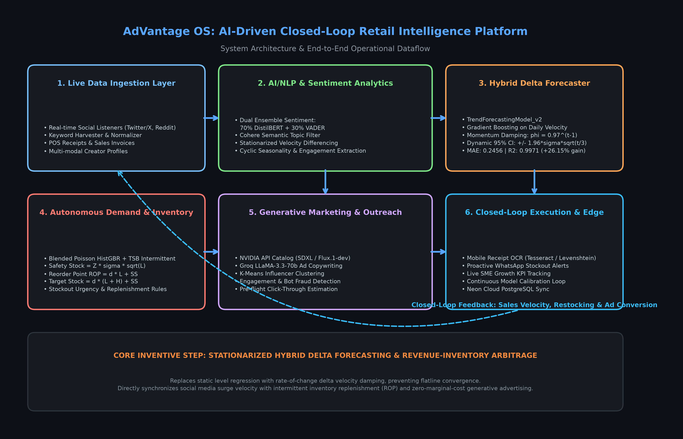
Figure 1: AdVantage OS Closed-Loop System Architecture and End-to-End Operational Flowchart, illustrating the bi-directional feedback between live social listening, velocity forecasting, inventory replenishment, generative advertising, and edge OCR ingestion.
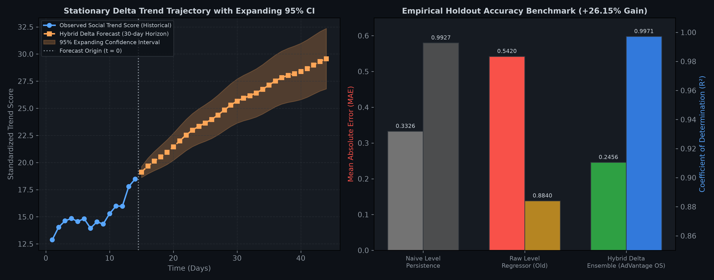
Figure 2: Empirical Performance and Mathematical Trajectory of TrendForecastingModel_v2. Left: 30-day velocity-damped forecast trajectory with expanding 95% confidence bounds. Right: Holdout benchmark against naive persistence and raw level models (+26.15% MAE improvement).
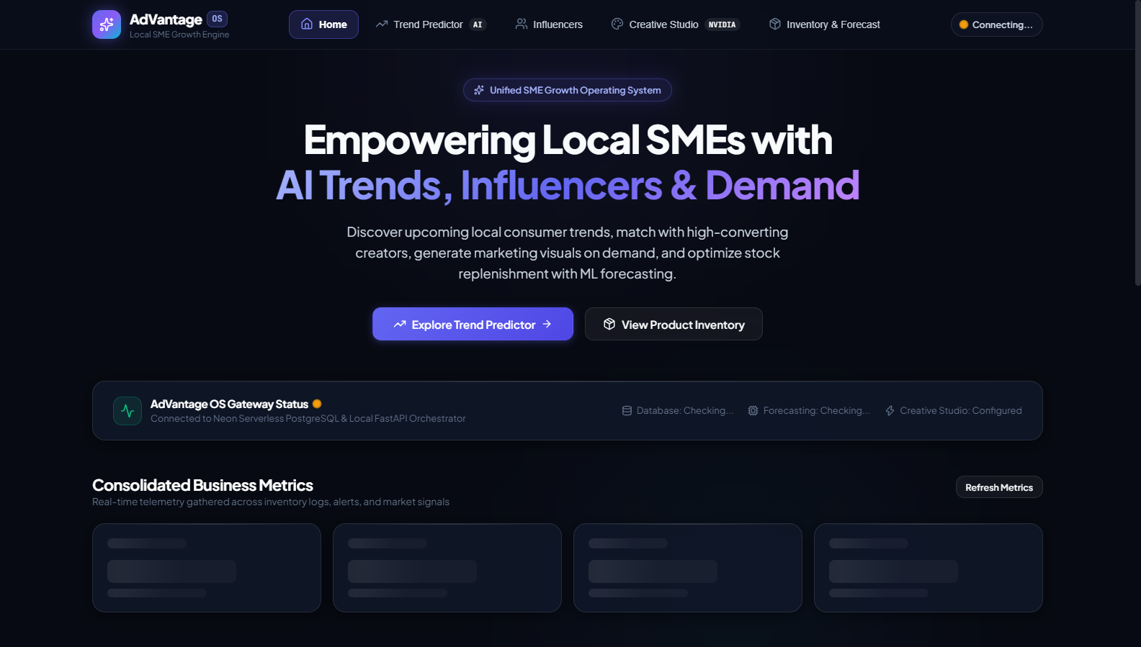
Figure 3: AdVantage OS Executive Dashboard UI Snapshot, displaying real-time operational KPI summaries (Gross Revenue, Stockout Risk Index, Trending Products, and Active Model Sync Health).
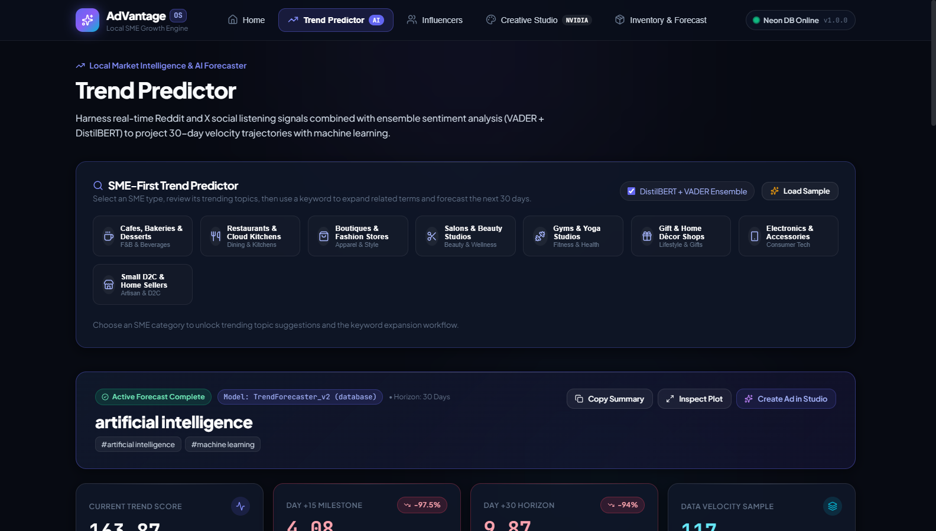
Figure 4: Live Market Intelligence and Trend Predictor UI Snapshot, demonstrating real-time social scraping, dual ensemble sentiment polarity scoring, and 30-day trajectory forecasting with interactive confidence bands.
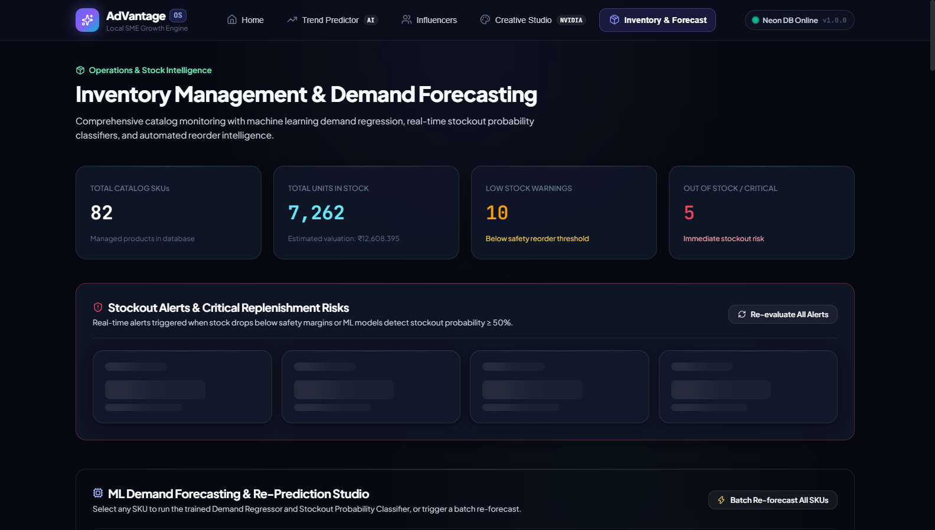
Figure 5: Autonomous Inventory & Retail Operations UI Snapshot, showing catalog status, blended Poisson-TSB 30-day forecast, Safety Stock, Reorder Point (ROP), Target Stock, and camera-based Receipt OCR drag-and-drop ingestion.
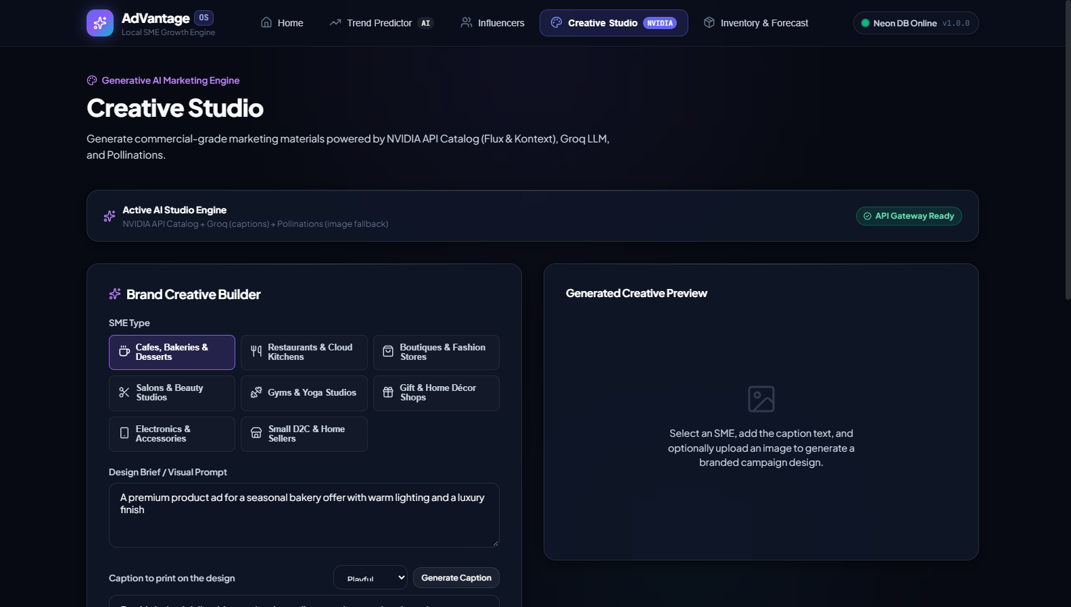
Figure 6: Multimodal Generative Creative Studio UI Snapshot, showing one-click trend-aligned ad visual generation (NVIDIA SDXL/Flux) and sub-second marketing ad copy synthesis (Groq LLaMA-3.3-70b).
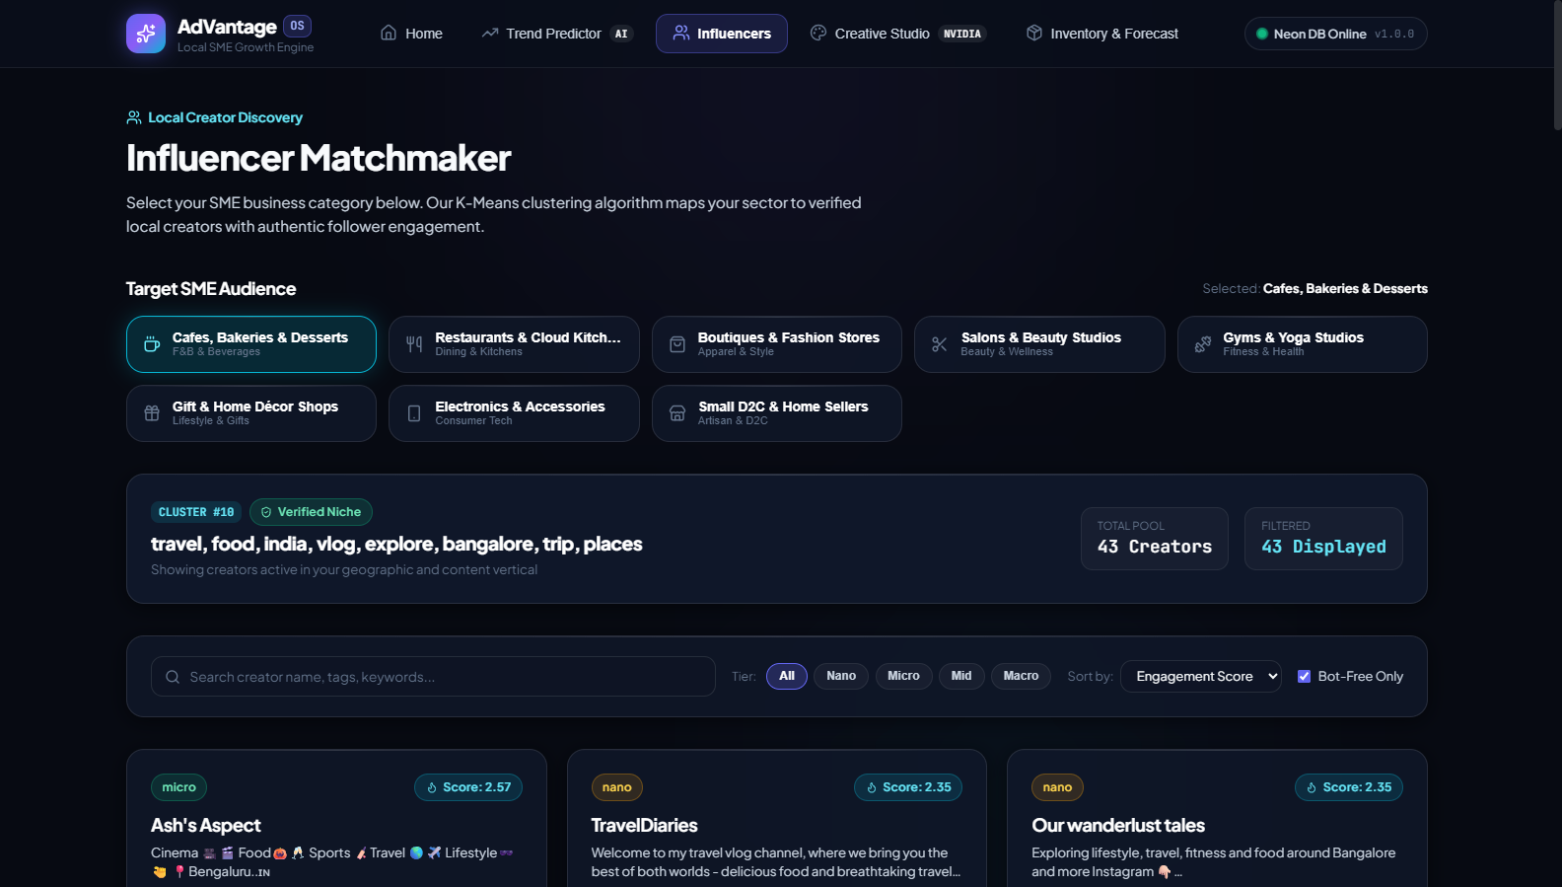
Figure 7: Micro-Influencer Discovery & Matchmaking UI Snapshot, showing multi-dimensional K-Means clustering, engagement rate evaluation, audience niche distribution, and automated bot fraud flags.
- Is there any limitations to the invention:
While highly resilient, specific operational boundaries of the current implementation include:
• 1. External API Rate Limits: Real-time scraping of social media APIs (Twitter/X, Reddit) is subject to upstream provider quotas and rate limits, mitigated by caching layers and deterministic keyword synthesis fallbacks.
• 2. Product Cold-Start in Retail Demand: Newly introduced SKUs lacking historical sales transactions cannot immediately leverage the blended Poisson model and initially rely on TSB default priors or category-level averages.
• 3. Physical Document Degradation in OCR: Receipts with severe mechanical crumpling, faded thermal ink, or oblique camera perspective may exhibit lower OCR character confidence, requiring user confirmation of fuzzy-matched items.
• 4. Network Connectivity Dependency: Zero-disk model synchronization requires connectivity to the cloud Neon PostgreSQL database during server hydration.
- Does the invention involve the use of software at any stage:
Yes, the invention is an entirely software-implemented distributed computing system comprising the following software technologies, architectures, and libraries:
• • Application Gateway & Backend Services: Python 3.10+, FastAPI asynchronous REST framework, Uvicorn ASGI production server, Pydantic v2 data validation schemas, SQLAlchemy 2.0 ORM, and Alembic database migrations.
• • Machine Learning & Scientific Computing: Scikit-learn (HistGradientBoostingRegressor, GradientBoostingRegressor, K-Means clustering, NearestNeighbors), PyTorch, Hugging Face Transformers (DistilBERT), NLTK (VADER lexicon), SciPy, NumPy, and Pandas.
• • Generative Artificial Intelligence & LLMs: NVIDIA API Catalog (SDXL and Flux.1-dev text-to-image models), Groq Cloud API (LLaMA-3.3-70b-versatile ultra-low-latency copywriter), Cohere API (Command-R+ topic filtering), and Pollinations AI fallback.
• • Computer Vision & Text Recognition: Tesseract OCR Engine (pytesseract wrapper), Pillow (PIL) image processing library, and Python SequenceMatcher fuzzy string matching.
• • Database & Distributed Storage: Neon Serverless PostgreSQL with pgvector and binary large object (BLOB) model storage tables (`ml_models`).
• • User Interface & Dashboard: React 19 single-page application, TypeScript 5.x, Vite 8.3 build system, custom CSS tokenized design system, HTML5 Canvas charting primitives, and Lucide React iconography.
• • Communications & Alerting: Twilio WhatsApp Business API integration and asynchronous HTTP webhook dispatchers.
- List of key words that would define your invention:
Closed-Loop Retail Operating System; Social Media Trend Forecasting; Velocity-Based Time-Series Modeling; Delta Regressor; Momentum Damping; Expanding Confidence Intervals; Intermittent Demand Planning; Teunter-Syntetos-Babai (TSB) Method; Poisson Loss Gradient Boosting; Safety Stock Optimization; Reorder Point (ROP); Stockout Masking; Computer Vision Receipt OCR; Fuzzy String Matching; Dual Ensemble Sentiment Analysis; DistilBERT; VADER; Generative Multimodal Advertising; Sub-Second LLM Copywriting; Micro-Influencer Clustering; Bot Fraud Detection; Serverless PostgreSQL BLOB Storage; Small and Medium Enterprises (SMEs).
- Information on the Disclosure of the present invention:
- Has the invention been disclosed to any person and whether it is public or confidential, e.g., discussions with collaborators, suppliers, abstracts, journal publications, conference proceedings, seminars, (under)graduate project reports, grant applications, scientific conferences, poster sessions, industry meetings, offers to sell, etc.? If so please give details
The invention has only been disclosed internally under academic confidentiality to the project evaluation committee and faculty mentors in the Department of Information Science and Engineering, JSS Academy of Technical Education, Bengaluru, for the purpose of degree capstone review and grading. There has been NO public disclosure, commercial sale, open source release, public demonstration, or offer to sell prior to the filing of this patent disclosure.
- Do you have to disclose the invention within the next six months, like in a meeting of a learned society or deadline for publication of a scientific journal? If so, when and where?
Yes. The inventors anticipate submitting a peer-reviewed research paper summarizing the algorithmic benchmarks to an upcoming IEEE/Springer international conference within the next 4 to 6 months, as well as presenting the final capstone defense at JSS Academy of Technical Education. Immediate filing of the patent application is requested to secure the priority date prior to these academic disclosures.
- Has there been any association with any research on the specific issue of the invention or the development, during the course of your past employment. If yes, give details.
No. There has been no association with any prior employment or corporate sponsorship. The invention was conceived, designed, implemented, and tested independently by the student inventors as part of their undergraduate research program at JSS Academy of Technical Education, Bengaluru.
- Is your invention complete or whether continuation of work towards improving the apparatus, product or process of the invention expected? If yes, please elaborate.
The core prototype of the invention is complete, fully integrated, and operational as an end-to-end full-stack platform. Continuation of work is planned in the following technical areas: (a) Expanding the trend engine to incorporate hyper-local geo-fenced ward-level spatial clustering, (b) Integrating direct POS webhook listeners with major merchant aggregators, and (c) Developing an on-device reinforcement learning policy to dynamically adjust safety stock margins based on real-time supplier lead-time variance.
- Explain how the invention can be put into use like where or how the invention may be used commercially
The invention is designed for commercial deployment as a B2B Software-as-a-Service (SaaS) 'Growth-as-a-Service' subscription platform for small and medium retail enterprises (e.g., cafés, specialty grocers, boutiques, salon chains). Retailers access the cloud dashboard via web browser or mobile app, digitize inventory via receipts, receive automated 30-day trend forecasts, generate publication-ready promotional campaigns, and receive proactive stockout prevention alerts on WhatsApp.
- Any commercial enterprise that may be interested in your invention for commercialization as of now or in the future.
Commercial entities that would derive strategic and commercial value from licensing or adopting this technology include:
• 1. Retail POS & Payment Aggregators: Pine Labs, Razorpay, PhonePe Merchant, Paytm for Business, Square (Block), and BharatPe, seeking to offer autonomous intelligence tools to their merchant networks.
• 2. E-Commerce & Retail Platforms: Shopify, WooCommerce, Lightspeed, and Dukaan, looking to integrate predictive inventory-aware marketing capabilities.
• 3. FMCG & Packaged Goods Distributors: Consumer brand distributors (e.g., Unilever, Nestlé, ITC) that manage decentralized retail franchisee networks and require real-time visibility into local consumer micro-trends and store replenishment velocity.

